Mutations in the DNA encoding for isocitrate dehydrogenases (IDH) are established molecular markers in 70-80% of stage II or III in glioblastoma. Among IDH1 mutations, R132H is the most common mutation in glioma (90%). IDH1-R132H is expressed in other cancers so the visualization of the dynamics of the cancerous cells within the brain, and their lineage tracking using an animal model could help as an early predictor for grades 2 and 3 glioma. There have been various promising experiments on mice regarding vaccinations, or immunizations targeting IDH1-R132H. Glioblastoma which is the most aggressive form of glioma is a fast-spreading form of glioma, understanding metastasis and migration in these cancer cells is a critical step towards better therapeutics.

**Biological question**: The aim of the research will consist in 1) investigate cell migration in term of speed and diffusion across tissues 2) develop a cancer brainbow animal model expressing IDH1R132H in the brain subventricular zone (SVS) to visualize expansion and spread of the oncogene IDH1R132H 3) characterize the dynamics of single-cancer cell.

* IDH1 localizes in the cytoplasm and peroxisome, and promotes the oxidative decarboxylation of isocitrate to alpha-ketoglutarate (-KG) that protects the cells from reactive oxygen species (ROS) which can cause DNA damage. Mutation in IDH1 forces the cells to convert -KG into the D isomer of 2-hydroxyglutarate (D2HG). A high concentration of D2HG is toxic for the glioma cells and induces biological alternations like causing oxidative stress, reduction of pro-inflammatory signalling and inhibition of expression of pro-apoptotic proteins.
* We will use the study by Bardella et al.[1] to generate a mouse model of glioma by expressing IDH1-R132H in the subventricular zone (SVZ) in the brains of adult mice. The IDH1fi(R132H)/+ knockin mice[1] showed hydrocephalsys and expanded lateral ventricles with an accumulation of D2HG and a reduction of -KG.
* Once the germline transmission of the mutant allele established, we will engineer and validate a cancer brainbow mouse model. We will follow the methodology detailed in Boone et al. [2]. The cancer rainbow (crainbow) transgene has 4 positions that either express an inert fluorescent protein (position 0), or 3 spectrally resolvable fluorescent proteins paired with an oncogenic mutation of choice (positions 1-3) which in our case, is the mutated IDH1R132H gene. Each R132H allele is co-expressed with TagBFP (cyan), mTFP1 (yellow), or mKO (magenta). The construct is further optimized to provide a rich fluorescent protein palette (XFP) by the expression of a membrane-targeted and chemically inducible near-infrared fluorogen-activating peptide (Fap-Mars1) as a control.
* We may introduce more than one copy of the Crainbow cassette in the nucleus to multiply the number of colors or different approaches for color cellular tagging which will make cell tracing and lineage analysis task easier.
* We will then follow a multi-step process to analyze the collective mobility of the brain cancer cells:
* Brain mouse organoids will then be made according to established protocols.
* We will then use an RNA Protein detection assay such as the RNAScope Kits from ACD to identify mRNA targets in FFPE tissues sections from crainbow mice brain.
* We will then follow a single-cell RNASeq protocol which will involve few steps:
* Cell isolation (we can use a single-cell isolator for single cell capture)
* Build of gene matrices (or expression matrix in single-cell RNASeq methodology)
* Then we will perform feature selection → by a dimensionality reduction → to build a cell-cell distance matrix
* Unsupervised clustering for identification of cell subpopulations such as stem cells and enterocytes.

Having identified clusters of subpopulations, we will then be able to track more easily cell migration:

* Tissues will be appropriately stained
* Imaging will be performed using a confocal microscope equipped with lasers
* Excitation laser and appropriate detector ranges will be used for multispectral acquisition of XFPs and fluorescent stains.
* We will need to find a microscope with built-in software to acquire time-lapses images.

We will then be in position using color-coded cell to perform a displacement analysis using the following metrics

* The mean squared displacement which describes the displacement of the same-color tag cells as the average distance of the subpopulations of cells (identified by the same color) in a given time interval, :

MSD = where N: total number of trajectories for all measured subpopulations

: starting position of the nth cell trajectory

: position of the nth cell after

* Instantaneous speed, , at the ith step of a cell as the displacement

= | **v** () | =

* The migration speed of a cell, V, is the mean over the entire length of the trajectory from i = 1 to the total number of steps L: =
* The velocity auto-correlation function (VACF) of the color tag ensemble average of cell trajectories:

VACF = < **v**(0) • **v**() > = (0) • ()

where (0) is the initial velocity of the nth cell and () is its velocity at time . Directionality is given by the ration between cross-product and dot product between position vectors at ti: **r**(ti), and ti-1: **r**(ti-1)

tan(θ) =

With these metrics we will analyze various plots using color-tagged ensemble of cancer cells:

counts(%) vs. density, MSD vs. time (, vs. time (, VACF vs. time (, angles distributions vs. time (

We will check then:

1. if the diffusion of migrating cells is characterized by a power law (MSD ~ , < 1: diffusion is sub-diffusive, 1 < < 2: diffusion is super-diffusive, = 2: diffusion is ballistic)
2. if there is correlation decay over time: VACF diminishes with increased if the cells velocities become uncorrelated due to interactions with the surrounding environment.
3. type of cell motion: log-normal, Brownian walk or Levy walk[2]. Any Brownian random walk model of cell migration will be characterized by a uniform distribution of turning angles, θ, between successive time samples.

[1] Bardella et al., 2016, Cancer Cell 30, 578–594 - October 10, 2016 - http://dx.doi.org/10.1016/j.ccell.2016.08.017

[2] Peter G. Boone - A cancer rainbow mouse for visualizing the functional genomics of oncogenic clonal expansion

Nature communications - <https://www.nature.com/articles/s41467-019-13330-y>

[3] Weissman TA, Pan YA. 2015 Brainbow: new resources and emerging biological applications for multicolor genetic labeling and analysis. Genetics 199(2):293- 306.

[4] Mehrjardi et al. Cell Death and Disease (2020)11:998 https://doi.org/10.1038/s41419-020-03196-0 - Current biomarker-associated procedures of cancer modeling-a reference in the context of IDH1 mutant glioma

[5] Woodworth et al.: Building a lineage from single cells: genetic techniques for cell lineage tracking - DOI: [10.1038/nrg.2016.159](https://doi.org/10.1038/nrg.2016.159)

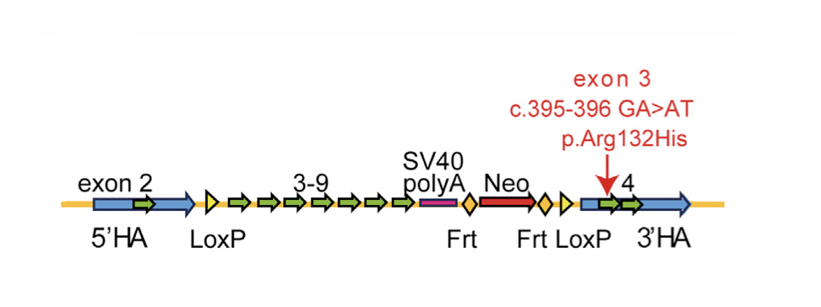

Construct used to generate IDH1-KI mice: loxP and Frt sites; 5’ and ‘homology arms; wild-type

mini-gene (exons 3-9), SV40 polyA signal, neomycin resistance cassette (NEOR), and location of the R132H mutation.

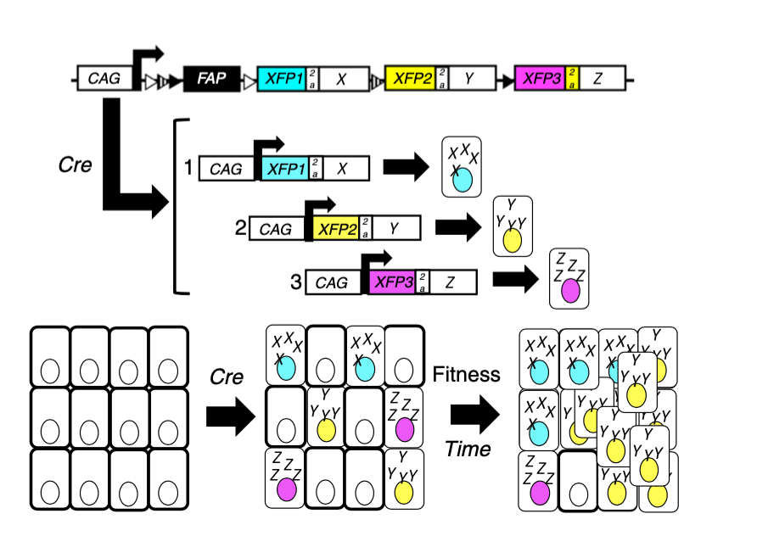

Stochastic Cre-mediated recombination and palette of colors for cell lineage

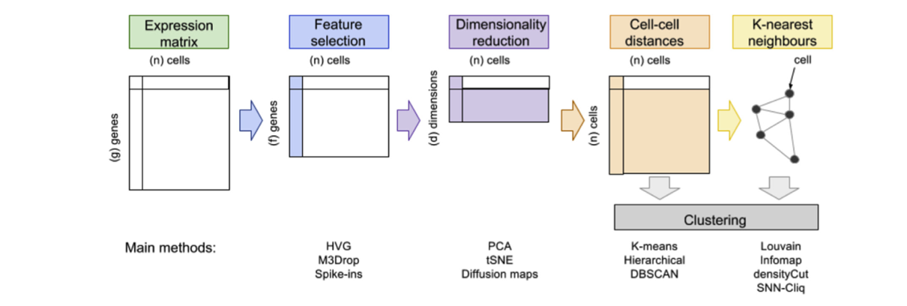

Overview of RNASeq protocol

1. The knock-in region comprised a 5’ loxP site, a wildtype min-gene (exons 3-9 and 3’UTR), an SSV40 polyA signal, a NeoR cassette flanked by Frt sites, and a 3’ loxP site.The LoxFtNwCD vector was injected into C57BL/6 ESS cells. The NeoR cassette was removed using Cre-mediated recombination and the R132H allele was knocked-in *in vivo*.
2. immune T-cell motion, which has been identified as either log-normal or a Lévy walk depending on the tissue they migrated in: G.M. Fricke, K.A. Letendre, M.E. Moses, J.L. Cannon, Persistence and adaptation in immunity: T cells balance the extent and thoroughness of search, PLoS Comput. Biol. 12 (2016) 1–23, and T.H. Harris, E.J. Banigan, D.A. Christian, C. Konradt, E.D.T. Wojno, K. Norose, E.H. Wilson, B. John, W. Weninger, A.D. Luster, et al., Generalized Lévy walks and the role of chemokines in migration of effector CD8+ T cells, Nature 486 (2012) 545.